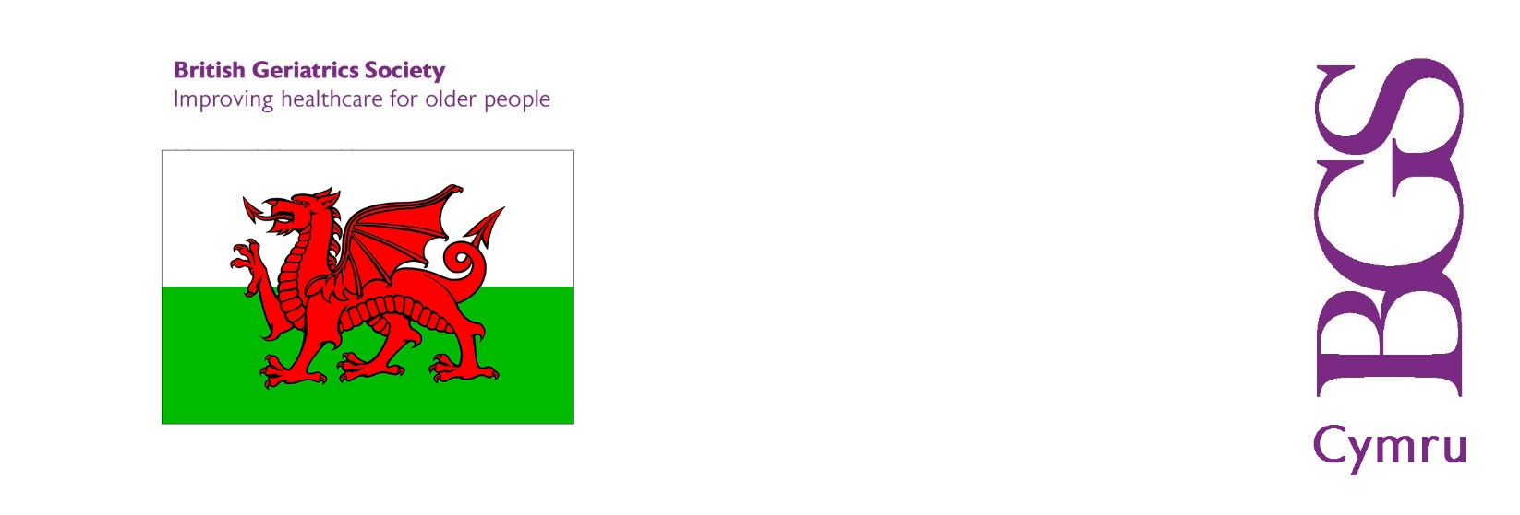

BGS WALES
Annual General Meeting
2022

AGENDA

Notice is hereby given that the 2022 Annual General Meeting of the Welsh Branch of the British Geriatrics Society will take place on Thursday 13 October commencing at 17.30 (until 18.00) for the purpose of conducting the following ordinary business:

1. To receive apologies for absence.
2. To note and approve the minutes of the 2021 AGM held on 23 September 2021 (attached).
3. To note the current composition of the BGS Wales Council Committee (attached).
4. To note the BGS Wales finance update (attached).

5. AOB

Dr Sam Abraham
Chair BGS Wales
October 2022

