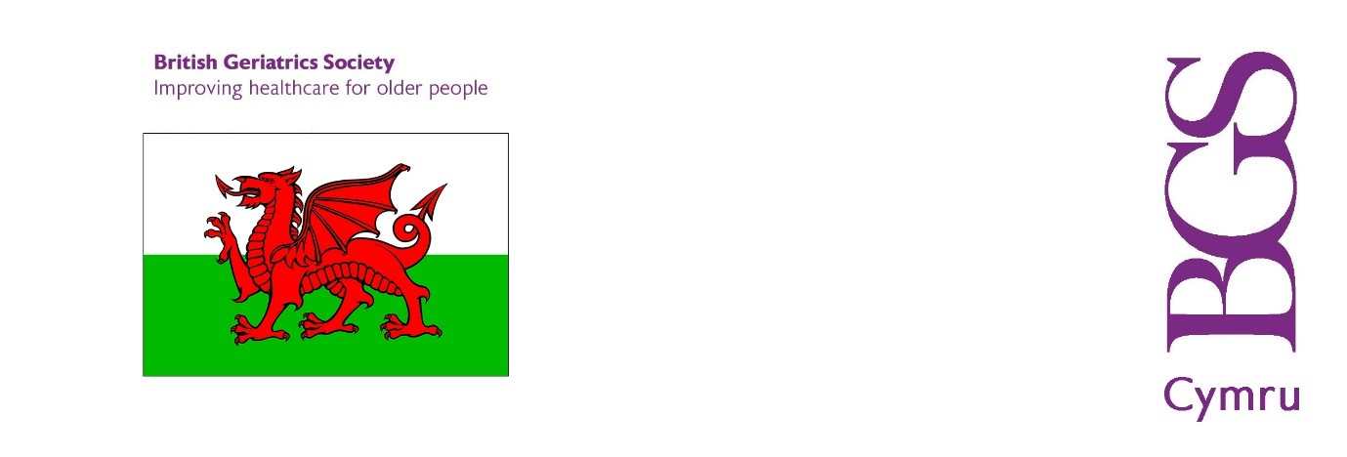BGS WALES 2021

Minutes of the Annual General Meeting

Held Thursday 23 September 2021 at 16.00

BGS Wales Council Committee: Dr Sam Abraham, Dr Anne Freeman, Dr Alex Elliott-Green, Dr Nicky Leopold, Wendy Mashlan, Dr Rhian Morse, Liz Wilcox, Dr Angela Nelmes, Dr Alex Elliot-Green.
BGS Wales Members: Dr Sandip Raha, Sinead O’Mahony, Dr Benjamin James Jelley, Dr Swapna Alexander, Dr Andrew Hayden.

BGS Secretariat: Sarah Mistry (BGS CEO), Janet Sarll, and Mark Stewart.
1. Apologies for absence
1.1 Formal apologies were received from Dr Karl Davis, Dr Sara Gerrie, Dr Walee Sayed,
Dr Vedamurthy Adhiyaman, and Dr Cameron Abbott.
2. To note and approve the minutes of the 2020 AGM held on 17 September 2020.
2.1 The minutes were agreed as an accurate record of the 2020 AGM.

3. To note the current BGS Wales Council Committee composition

3.1 The current Council Committee composition was noted; minor corrections were recorded.

4. To note the BGS Wales finance update

4.1 At 31 March 2021, BGS Central held £56,881 (2020: £57,111) on behalf of BGS Wales. The fund has been audited by BGS auditors Sayer Vincent and is separately identifiable in BGS Statutory Accounts for the year ended 31 March 2021.

4.2 The finance update was noted and briefly summarised by Janet Sarll, BGS Director of Business Support.
4.3 There has been little movement in the region’s finances since the last meeting. The annual Woodhouse Prize has been paid; and delegate fees of about £1,250 have been received for the Wales autumn meeting.
4.4 Glyn P. Jones Trust: Graham Boswell, the sole trustee of the fund, will be encouraged to complete the arrangements to have the funds sold and transferred to BGS central. BGS Central will give support as necessary.

4.5 Arts Prize: no award has been made since the last meeting. Dr Susan White to be contacted to update the Council Committee on progress
4.6 Delirium booklet: Dr Karl Davis to be contacted to update the Council Committee on progress.
4.7 The BGS is reviewing its existing range of grants and prizes with a view to making these more streamlined, raising their profile and opening up eligibility.
4.8 On behalf of those present, Dr Abraham formally approved the Finance Report.
5. AOB

5.1 The Marjory Warren Lifetime Achievement Award 2021: this year’s award was given posthumously to the candidate put forward by BGS Scotland, Professor John Starr.

5.2 BGS Wales agreed to re-nominate its 2021 candidate, Professor Tony Bayer, for the 2022 award.

6. Future AGMs

It was agreed that:
- The 2022 Annual General Meeting will be at the BGS Wales meeting in September 2022.

