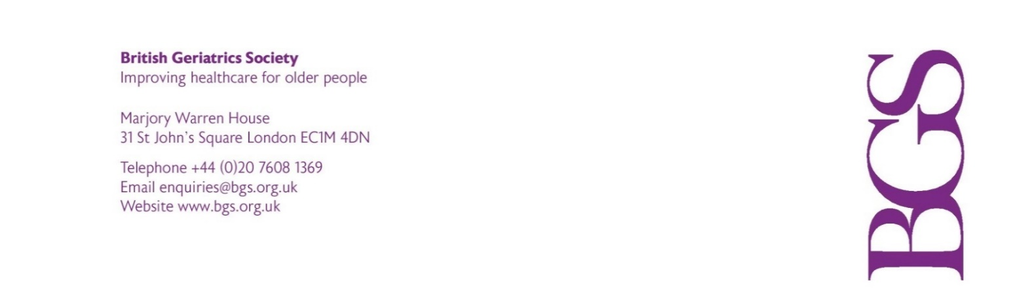
Proxy Form

BGS Northern Ireland
Annual General Meeting

to be held on

Thursday 20 October 2022

I (block capitals) a member of the above named Company, hereby appoint the Chair of the meeting, Dr Sam Abraham as my proxy to vote on my behalf in accordance with the following instructions at the Annual General Meeting of the Company to be held at 13.30 on Thursday 20 October 2022 and at any adjournment thereof.

Signature

Date
 |  | For | Against | Vote Withheld
Resolution One
To note and approve the minutes of the 2021 AGM held on 21 October 2021
Resolution Two
To formally note the appointment of Dr Gerry Sloan as Chair of BGS Northern Ireland.

Resolution Three
To note the BGS Northern Ireland finance update.

Notes:

- A member may appoint a proxy of his/her own choice. If such an appointment is made, delete the words “the Chair of the meeting” above and insert the name of the person appointed proxy in the space remaining.
- If you wish your proxy to cast your votes for or against a resolution you may insert an ‘X’ in the appropriate box. If you do not want your proxy to vote on any particular resolution, you may insert an ‘X’ in the ‘Vote withheld’ box. A ‘Vote withheld’ is not a vote in law and will not be counted in the calculation of votes ‘For’ or ‘Against’ a resolution. If you do not indicate how your proxy is to vote, you will be deemed to have authorised your proxy to vote or to withhold your vote as your proxy sees fit.

- To be valid, this form must be completed and returned to the registered office of the Company before Tuesday 18 October 2022 at 15.00 (48 hours before the time fixed for holding the meeting).

Please email your completed form to:
Mark Stewart, BGS Office and Business Manager:
M.Stewart@bgs.org.uk

Patron HRH The Prince of Wales
Limited company registered in England 1189776 Registered charity number 268762
Registered office: Marjory Warren House 31 St John’s Square London EC1M 4DN

