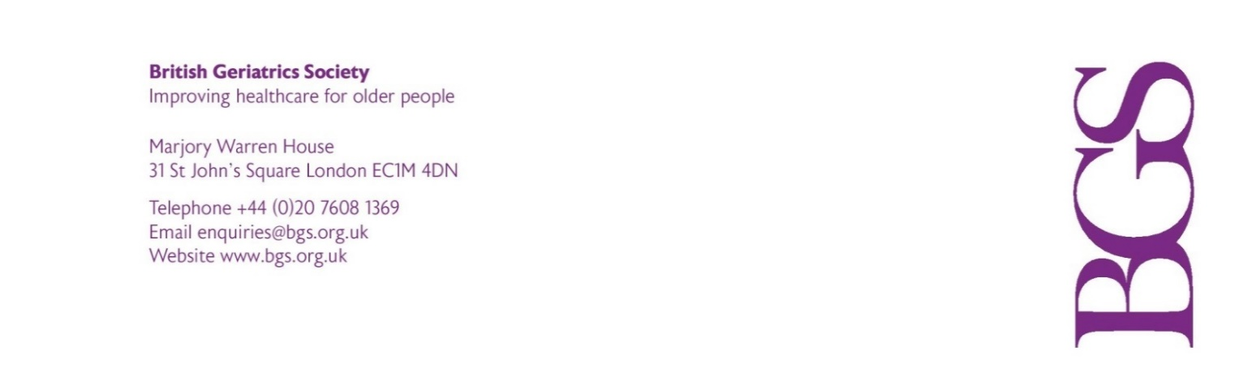
BGS Northern Ireland
Thursday 20 October 2022 at 13.30
Via MS Teams
AGENDA

Notice is hereby given that the 2022 Annual General Meeting of the Northern Ireland Branch of the British Geriatrics Society will take place on Thursday 20 October at 13.30 (until 14.00) for the purpose of conducting the following ordinary business indicted below.

- To receive apologies for absence.

- To approve the minutes of the 2021 AGM (attached).

- To formally note the appointment of Dr Gerry Sloan as Chair of BGS Northern Ireland.

- To note the audited BGS Northern Ireland funds held at BGS Central for the year ended 31 March 2022: At 31 March 2022 BGS held £9,295 (2021: £12,413) on behalf of BGS Northern Ireland.

- To note that the next AGM will take place in October 2023.

- AOB

Dr Gerry Sloan
Chair BGS Northern Ireland
October 2022

