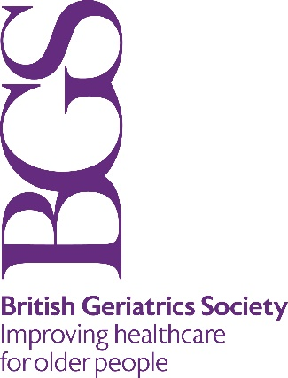

BGS grant support towards EAMA tuition and accommodation fees for 2024-2026 course

Application Form

Please email along with your tailored CV and other supporting documents to:

j.gough@bgs.org.uk

by midnight on 21 April 2023

Applicant Information
Title: |  | First Name: |  | Surname:

Grade:

BGS Member? | YES | NO

Address:

Postcode:
Nationality
Date of birth
Place of birth
Gender

Contact No. (Daytime) |  | Contact No.  (Evening)

Email:

Employer:

University Degree
University:
Faculty
Year:
Subject:
Other degree?:

Doctoral Fellowship:
Subject:
Faculty:
Year:
Please attach a PDF of your abstract

Topics of Research:

Research Supervisors:

Why do you wish to attend the EAMA course? (200-250 words)

How do you envision your career path? How might attendance at the EAMA course help your career?

How would you share your learning from the course with the BGS membership at large?

Have you checked the 2024 and 2026 course dates with EAMA? Are you available to attend them? | YES | NO

Supporting Documents (please list)

List of previous publications

Are you able to raise some of the course fees through other sources? (Suggested level: 50%)

Will you be able to cover your own travel expenses? | YES | NO

Do you undertake to repay any BGS grant in full if you fail to complete the course for any reason? | YES | NO

Applicant’s signature: |  | Date:

Signature of Training Programme Director or Head of Service |  | Date:

Please email along with your tailored CV and other supporting documents to:

j.gough@bgs.org.uk

by midnight on 21 April 2023

