Parkinson’s Disease – What Can We Learn from Outside of Healthcare?

Introduction

We are on the brink of a transformation that some experts are calling a Fourth Industrial Revolution (Industry 4.0). Building on the third digital revolution, which greatly shaped healthcare over the last half-century, Industry 4.0 has seen an exponential rise in technologies such as gene editing, advanced robotics, and quantum computing. This revolution is defined by technologies that blur the lines between physical, digital, and biological realities. For example, in artificial intelligence (AI) our knowledge of the human brain has been used to develop computers that can learn without being explicitly programmed. This has enabled machines to develop capabilities that far exceed those of humans.

Companies such as Google’s Deep Mind are already using AI to transform our day-to-day lives. From self-driving cars and drones to facial recognition software and virtual reality. In healthcare, AI systems can predict breast cancer risk¹ , diagnose lung cancer² and predict protein structure³. AI’s ability to identify hidden patterns in large, complicated datasets makes it particularly suited to the field of neuroscience. In this field techniques like functional magnetic resonance imaging and electroencephalography generate datasets that are either too large or too complicated to be accurately analysed by humans.

Parkinson’s Disease (PD) was first described as a medical disorder over 200 years ago. However, despite intensive research there is still no treatment that can prevent the neurodegeneration that underlies disease progression. AI has the potential to provide novel insights where humans have so far failed. This essay will aim to address the question: What can artificially intelligent machines teach us about Parkinson’s Disease?

An introduction to Artificial Intelligence

Simply, AI combines computer science and large datasets to develop intelligent computer programmes that solve problems autonomously. Most recent advances in AI have involved machine learning; a subfield of AI that focuses on imitating the way humans learn, using data and algorithms. One advanced form of machine learning uses neural networks - algorithms modelled on the human brain. In neural networks, nodes are organised into layers. Mathematical weights form connections between each layer, analogous to synapses between neurones (See Figure 1). With training, the networks learn which connections need to be strengthened to increase the accuracy of their output. Such networks can detect patterns in data that humans cannot.

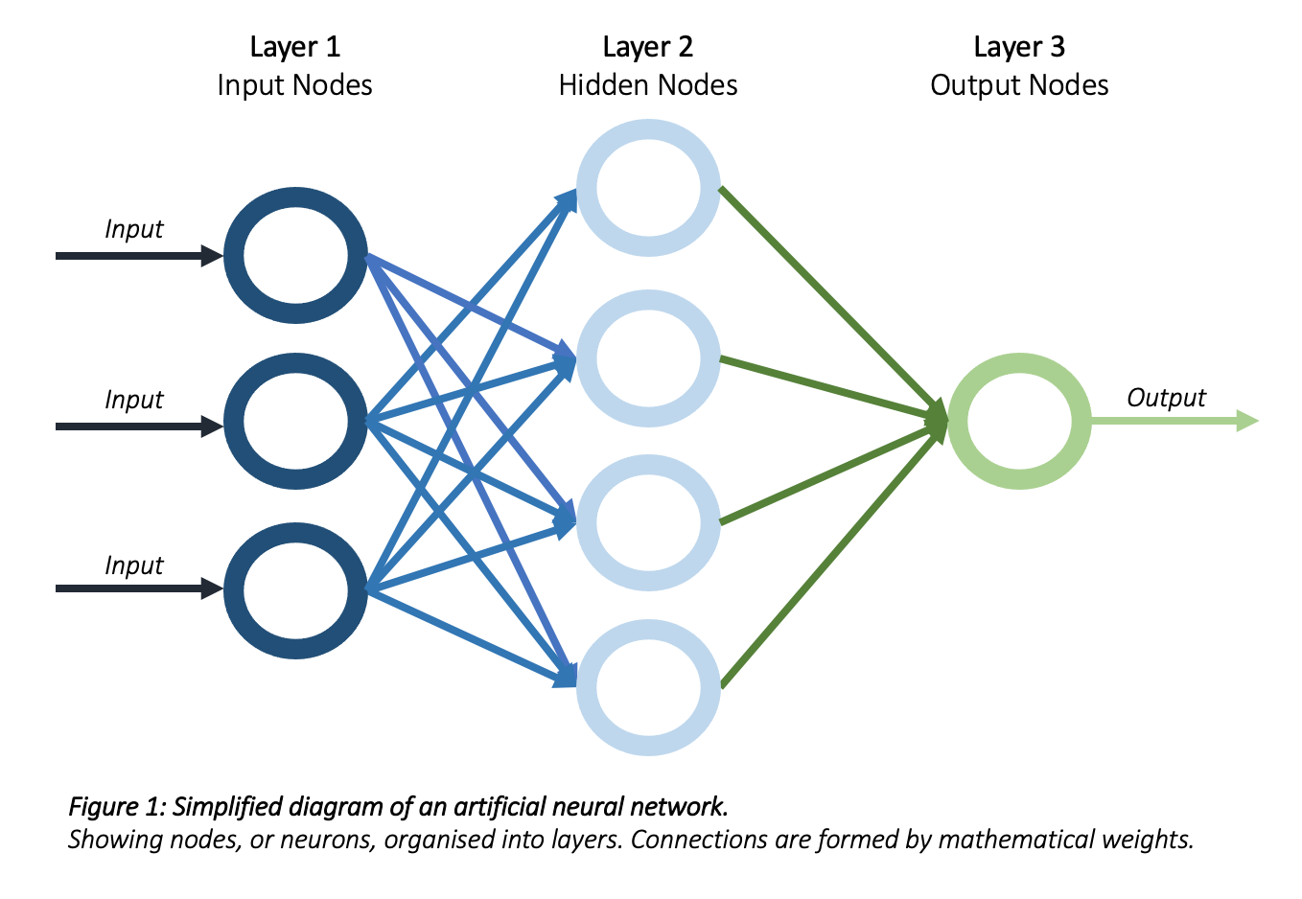

What has artificial intelligence taught us about Parkinson’s Disease?

Diagnosis
PD diagnosis before onset of overt motor symptoms is crucial for early intervention and pre-emptive enrolment into clinical trials. Currently, studies suggest that the sensitivity of PD diagnosis in patients with early-stage disease that are not responsive to levodopa may be as low as 26%⁴. This is because, in the absence of a conclusive test, the diagnosis of PD is clinical. However, the early signs and symptoms of PD are often subtle, varied, and difficult to assess clinically (e.g., depression, anosmia and somnolence).

AI systems are searching for early PD manifestations that may represent novel disease biomarkers. These biomarkers could be used to increase the accuracy of early PD diagnosis. Data modalities under investigation include patients gait patterns, neuroimaging results and cerebrospinal fluid⁵. Remarkably, one AI system has even identified changes in the voice recordings of patients with PD that enable differentiation between PD patients and healthy controls with 100% accuracy⁶. This may enable acoustic analysis of voice signals to diagnose PD and track disease progression.

Monitoring
The application of AI is facilitated by digital technologies (e.g., wearables and smartphones) that record data as patients carry out normal daily activities. This enables clinicians to monitor patients continuously, rather than just a snapshot assessment in clinic. This is especially important in a disease like PD where symptom severity fluctuates.

A recent clinical trial by Lipsmeier et al⁷ investigates the potential of AI in home monitoring. For six months, participants carried a smartphone throughout the day (passive monitoring) and used the smartphone to complete daily motor function tests (active monitoring). A machine learning algorithm was used to classify the data. The monitoring system could successfully discriminate between PD patients and healthy controls. Furthermore, the algorithm also detected abnormalities in PD patients that had no signs on the corresponding MDS-UPDRS scoring system; a tool widely used to gauge PD severity and progression. This indicates that patients may be living with subtle symptoms of PD that are not visible to clinicians but may have a significant impact on their quality of life.

Management
Machine learning is being used for more than just PD diagnosis. AI-based remote monitoring systems also enable symptom management to take place in real time. For example, one of the most disabling symptoms of PD is the freezing of gait (FoG) phenomenon. FoG increases risk of falls and profoundly reduces patient’s independence and mobility. Neural networks have been trained to detect and even predict when FoG episodes are about to occur using data collected from wearable sensors⁸. Continuous data collection enables the neural network to identify person-specific predictors of FoG and automatically provide sensory cueing that should enable the patient to resume walking⁹.

Machine learning is also being used to analyse signals from PD patients’ brains in order to detect pathological brain states. For example, local field potentials (LFP’s) recorded from electrodes implanted in the subthalamic nucleus of patients with PD have been analysed by machine learning systems to look for patterns in the electrical activity that may correlate with disease manifestations. They found that bursts of beta oscillatory activity (13-30Hz) are consistently found in the subthalamic nucleus of patients with PD and their frequency correlates with degree of motor impairment¹⁰. In a proof of principle study, Little et al 2013¹¹ developed a brain-computer-interface that could recognise pathological brain activity in patients with PD and could use this to determine when therapeutic deep brain stimulation (DBS) should be delivered. This type of closed-loop technology could be invaluable in a condition like Parkinson's Disease where symptoms fluctuate continuously.

Prognosis
As described above PD is highly variable in its presentation, but also in rate of progression; in some patients the disease progresses rapidly whilst in others the disease follows a benign disease course that never progresses to severe disability. Using longitudinal data collected from 423 patients for up to seven years, Severson et al¹² applied machine learning technology to look for disease subtypes. Unexpectedly, the algorithm found that rather than there being several distinct disease subtypes with unique patterns of progression, there are instead overlapping disease progression trajectories, suggesting that subtypes are not static. This suggests that models of PD progression should not be deterministic. Theoretically, understanding how and why patients move between different disease trajectories could be useful for both prognostication and potentially steering patients towards a more benign disease course.

Disease mechanisms
One major barrier in PD research is our limited understanding of how a healthy human brain works. If we do not understand the normal brain, how can we hope to understand a disease like PD? In this area AI has come full circle. While initially the structure of the human brain was used to develop machine learning systems like neural networks, these neural networks are now being used to help us understand brain function. Theoretically, if an algorithm can be trained to behave like a brain - meaning that the pattern of activity in the artificial network resembles the pattern of electrical activity recorded in the brain - scientists can examine the algorithm to determine how the brain might be generating a similar output (see Savage et al¹³ for a review).

By extension, once we have AI models that can faithfully recapitulate the healthy human brain, perturbation of these models may allow us to explore what might be happening in the diseased brain. For example, what must change for a model of the basal ganglia to generate an output that resembles the electrical signals recorded from the brain of a patient with Parkinson's Disease?

Currently, this remains an area for future development. Most computer-based studies investigating PD mechanisms use computational modelling rather than AI. Several computational models have investigated the mechanisms underlying PD motor symptoms¹⁴. Others have simulated the process of neuronal death in the basal ganglia¹⁵. However, while computational models are powerful tools for understanding large systems, they are not able to make decisions autonomously or learn over time like AI can, limiting their ability to offer novel insights.

Conclusion

Although still in their infancy, AI has already made important contributions to our understanding of PD, particularly in the discovery of subtle disease manifestations and characteristic electrical patterns in the brain. The wealth of information that can be harnessed by wearable technologies also has the potential to provide an unprecedented insight into the impact that PD has on patients day-to-day. In the future, the lines between physical and the biological sciences will become further blurred with the development of AI models of the human brain that may offer insights into the mechanisms underlying PD. Soon the fields of computer science and healthcare are likely to become intrinsically linked.

Word Count: 1493

References

- McKinney SM, Sieniek M, Godbole V, Godwin J, Antropova N, Ashrafian H, et al. International evaluation of an AI system for breast cancer screening. Nature. 2020 Jan;577(7788):89–94.

- Joy Mathew C, David AM, Joy Mathew CM. Artificial intelligence and its future potential in lung cancer screening. EXCLI Journal; 19:Doc1552; ISSN 1611-2156 [Internet]. 2020 [cited 2022 May 26]; Available from: https://www.excli.de/index.php/excli/article/view/3095

- Jumper J, Evans R, Pritzel A, Green T, Figurnov M, Ronneberger O, et al. Highly accurate protein structure prediction with AlphaFold. Nature. 2021 Aug;596(7873):583–9.

- Adler CH, Beach TG, Hentz JG, Shill HA, Caviness JN, Driver-Dunckley E, et al. Low clinical diagnostic accuracy of early vs advanced Parkinson disease: Clinicopathologic study. Neurology. 2014 Jul 29;83(5):406–12.

- Mei J, Desrosiers C, Frasnelli J. Machine Learning for the Diagnosis of Parkinson’s Disease: A Review of Literature. Frontiers in Aging Neuroscience [Internet]. 2021 [cited 2022 Feb 19];13. Available from: https://www.frontiersin.org/article/10.3389/fnagi.2021.633752

- Hariharan M, Polat K, Sindhu R. A new hybrid intelligent system for accurate detection of Parkinson’s disease. Comput Methods Programs Biomed. 2014 Mar;113(3):904–13.

- Lipsmeier F, Taylor KI, Kilchenmann T, Wolf D, Scotland A, Schjodt-Eriksen J, et al. Evaluation of smartphone-based testing to generate exploratory outcome measures in a phase 1 Parkinson’s disease clinical trial. Movement Disorders. 2018;33(8):1287–97.

- Mazilu S, Hardegger M, Zhu Z, Roggen D, Troester G, Plotnik M, et al. Online Detection of Freezing of Gait with Smartphones and Machine Learning Techniques. In 2012 [cited 2022 May 20]. Available from: https://eudl.eu/doi/10.4108/icst.pervasivehealth.2012.248680

- Pardoel S, Kofman J, Nantel J, Lemaire ED. Wearable-Sensor-based Detection and Prediction of Freezing of Gait in Parkinson’s Disease: A Review. Sensors (Basel). 2019 Nov 24;19(23):E5141.

- Tinkhauser G, Torrecillos F, Pogosyan A, Mostofi A, Bange M, Fischer P, et al. The Cumulative Effect of Transient Synchrony States on Motor Performance in Parkinson’s Disease. J Neurosci. 2020 Feb 12;40(7):1571–80.

- Little S, Pogosyan A, Neal S, Zavala B, Zrinzo L, Hariz M, et al. Adaptive deep brain stimulation in advanced Parkinson disease. Annals of Neurology. 2013;74(3):449–57.

- Severson KA, Chahine LM, Smolensky LA, Dhuliawala M, Frasier M, Ng K, et al. Discovery of Parkinson’s disease states and disease progression modelling: a longitudinal data study using machine learning. The Lancet Digital Health. 2021 Sep 1;3(9):e555–64.

- Savage N. How AI and neuroscience drive each other forwards. Nature. 2019 Jul 24;571(7766):S15–7.

- Pavlides A, Hogan SJ, Bogacz R. Computational Models Describing Possible Mechanisms for Generation of Excessive Beta Oscillations in Parkinson’s Disease. Graham LJ, editor. PLoS Comput Biol. 2015 Dec 18;11(12):e1004609.

- Muddapu VR, Mandali A, Chakravarthy VS, Ramaswamy S. A Computational Model of Loss of Dopaminergic Cells in Parkinson’s Disease Due to Glutamate-Induced Excitotoxicity. Front Neural Circuits. 2019 Feb 25;13:11.

