Parkinson’s – what can we learn from outside healthcare?
Isabelle Shaw

The first time I met a patient with Parkinsons disease. I have to say the encounter was nothing like I expected. I had studied textbooks filled with characteristic features, clinical signs and pharmacological therapies. When I called Mr T from the waiting room he slowly but purposefully made his way toward me. During that consultation, I noticed his pill-rolling tremor, and his stiff, shuffling gait. But he also told me about all the things I had not read in my trusty textbooks. How he had noticed his handwriting changing in his daily diary entries, long before he sought help from his doctor. How he believed physical exercise to be the best way to slow the progression of the disease. And how walking with a stick had been his saving grace, letting him forget about his “droopy arm”.

As I near the end of medical school I reflect on all the instances where I have encountered Parkinson’s. I have seen Parkinson’s be misdiagnosed and missed. I have met patients who are seriously ill themselves but are solely concerned about returning home to care for their loved one who has Parkinson’s. Finally, I have seen relations and friends adapt to the challenges that the disease brings. The theme that runs through all of these interactions is a need for access to care and support. What can we learn from other industries? How can we achieve reliable, flexible, and rapid access to care? How can we prepare patients for the overwhelming journey ahead? In this essay, I will explore the lessons that can be learned from the aviation industry. I will discuss how an alternative perspective could minimise harm and regain control for those living with Parkinson’s.

Why do Parkinson’s patients need access to Healthcare?
Parkinson’s is a neurodegenerative disease which impairs the brain’s ability to produce dopamine, there is currently no cure. People affected by Parkinson’s typically experience bradykinesia, rigidity and tremor. But symptoms are varied and often include speech, memory and mood problems¹. In advanced disease, patients need frequent input from health professionals and carers. According to the 2018-19 English Hospitals Admissions statistics, there were 6,878 hospital admissions due to Parkinson’s disease. Over half of these were emergency admissions. The mean length of stay was 15 days². The most common reasons for admissions in Parkinson’s patients are falls, urinary tract infections and Parkinson’s dementia³. Poor standards of care for Parkinson’s patients in the hospital have been identified by specialist clinicians. Suggestions for improvement include specialist nurse input, and early identification of inpatients with Parkinson’s⁴. There is far more to managing Parkinson’s than my textbooks might have suggested and a holistic approach is required. To achieve this multi-disciplinary teams must engage with patients and their carers, and a system must be set up to account for unpredictable levels of need. The question is how do we prepare for a journey when we cannot see what lies ahead?

Aviation and the journey ahead
Think about the last time you boarded a plane. Your journey will be shorter and far less turbulent than a patient with Parkinson’s 20-30 year journey⁵. Nonetheless, there are lessons to be learned from the way that the aviation industry prepares its passengers for this journey. No one can completely anticipate the needs of the passengers before the plane takes off however, work processes and organisation can help to prepare for a variety of hazards. Before taking off the pilots and flight attendants will use checklists to ensure everything on the plane is still working and available for use. The simple introduction of pre-flight checklists revolutionised aviation safety⁶. As the passengers settle in their seats the airline staff will go through what the journey might entail. How long it might take, how to get something to eat and drink, how to get to the toilet, and where the nearest exits are. They will run through the worst case scenarios, how to get help and keep yourself safe. Smaller planes will even seat able passengers near the door and inform them of how to open the doors in an emergency. Each passenger has access to assistance by pushing a button which will alert the flight attendant. Translating some of these strategies and applying them to Parkinson’s care could help to improve accessibility to services.

Separated from life on the ground airline crew travel with a host of safety equipment. These include oxygen systems, fire extinguishers, and life-saving medications. This could be considered as their toolbox, they know what tools are inside and to some extent so do the passengers⁷. The toolbox aims to ensure the safety of passengers if an accident happened during the journey. Thinking back to Mr T and all the other patients I have met with Parkinson’s they all have different needs. Furthermore, it is difficult to predict when they may need additional help as symptoms fluctuate and secondary illness can occur at any time. A flexible toolbox approach encourages systems thinking, this is a perspective which has been adopted by the aviation industry⁸ (Figure 1). In contrast, stepwise protocols are likely to encourage linear thinking. The concept of a toolbox for those affected by Parkinson's has begun to be implemented by the NHS⁹. However, this is yet to be published in patient-facing format. Not all the passengers will be able to put their oxygen masks on in time if only the flight attendants know about them.
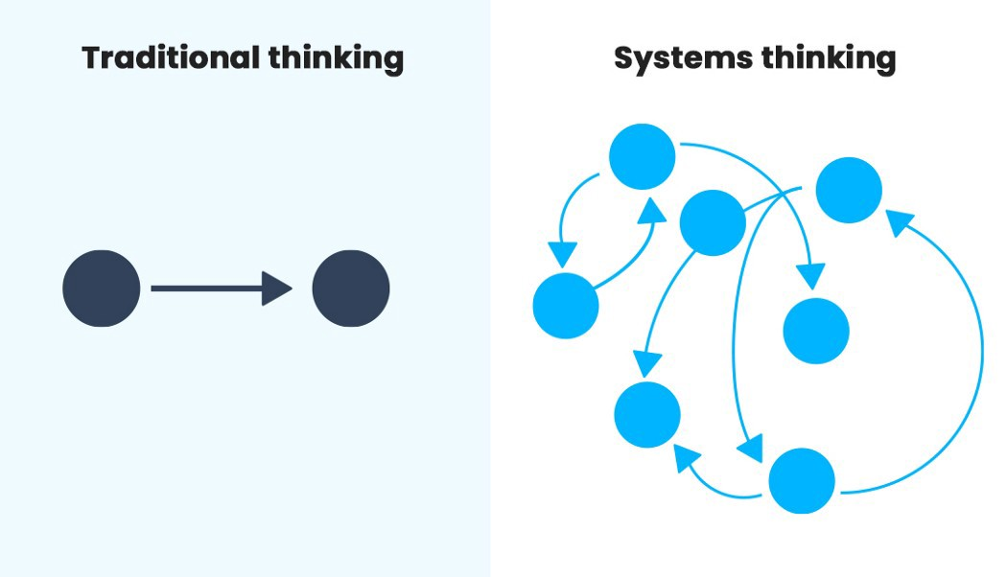
Figure 1) Diagram demonstrating linear thinking compared to systems thinking¹⁰.

Whilst airlines use call buttons to help their passengers to call for assistance, the world of healthcare has begun to invest in remote consultations. Following the COVID-19 pandemic, 99% of GP practices in England now utilise remote consultations¹¹. Telephone and video consultations make care more accessible to those who live rurally and can provide a window into the patient's home environment. By contrast, difficulties may arise for Parkinson’s patients affected by low voice volume and tremors when communicating remotely. From a clinician's perspective, a thorough neurological examination using telecommunications is under development but yet to be achieved¹². This concept of faster access to consultations alongside the existing access to specialist nurses could help patients to avoid a crisis point and admission. Ensuring that patients are given information about the disease from ‘take off’ would be a vital adjunct here. As it can enable them to identify when their symptoms are a sign of progression or undertreatment, and when to reach for support.

Airlines inform passengers of their safety procedures so that passengers can help themselves as much as possible if an incident were to happen. By giving able passengers the ability to open the emergency exit doors they ensure that less able people and young children can exit the aircraft safely. Similarly, healthcare providers should be equipping patients and carers with the tools and information to get help. For example, self-medication has been one of the strategies suggested by specialists to improve inpatient safety⁴. ‘PD self’ is one American Organisation which is focused on empowering newly diagnosed patients with Parkinson’s¹³. Beyond patient impacts, empowerment in a stretched healthcare system can preserve resources whilst improving patient satisfaction¹⁴. Signposting patients to services and support groups should therefore be an important component of the toolbox approach.

Conclusion
Knowing that this patient group require fluctuating levels of care over a long period and having identified that patients affected by Parkinsons require a holistic approach. The structural organisation of Parkinsons care could benefit from a protocol initiated at diagnosis and a toolbox which is used by patients and coordinated by healthcare providers. The main learning points to be taken from this comparison of aviation and Parkinson's care are anticipation of needs, systems thinking, easy access to assistance, and informed and involved service users.

References
- BMJ (2022) Parkinsons Disease. BMJ best practice. Available at: https://bestpractice.bmj.com/topics/en-gb/147. (accessed: 15/05/2022).
- English Hospital Episode Statistics. (2019) Hospital Admitted Patient Care Activity 2018-19. Available at: https://digital.nhs.uk/data-and-information/publications/statistical/hospital-admitted-patient-care-activity/2018-19 (accessed: 20/05/22).
- English Hospital Episode Statistics. (2016) Hospital Admitted Patient Care Activity 2015-16. Available at: www.content.digital.nhs.uk/hes (accessed: 20/05/22).
- Skelly, R., Brown, L., Fakis, A., Walker, R. (2015) Hospitalization in Parkinson's disease: A survey of UK neurologists, geriatricians and Parkinson's disease nurse specialists, Parkinsonism & Related Disorders,21(3), pp. 277-281.
- Ishihara LS, Cheesbrough A, Brayne C, et al (2007) Estimated life expectancy of Parkinson’s patients compared with the UK population. Journal of Neurology, Neurosurgery & Psychiatry, 78:1304-1309.
- Gerstle, C. (2019) Parallels in safety between aviation and healthcare, Journal of Pediatric Surgery, 53(5), pp. 875-878.
- HRD Aero Systems. 2018. What Safety Equipment Is On An Aircraft? | HRD Aero Systems. [online] Available at: <https://www.hrd-aerosystems.com/blog/what-safety-equipment-is-on-an-aircraft/> [Accessed 24 May 2022].
- Patankar, M., 2012. Safety culture. Burlington, Vt.: Ashgate Pub. Co.
- Rightcare (2019) Neurodegenerative conditions toolkit. Available at: https://www.england.nhs.uk/rightcare [Accessed 12 May 2022].
- Santhosh, G., 2018. How does Systems Thinking help Design Thinking?. [online] Medium. Available at: <https://bootcamp.uxdesign.cc/how-does-systems-thinking-help-design-thinking-4553a7133e38> [Accessed 15 May 2022].
- Dorsey ER, Bloem BR, Okun MS. A new day: the role of telemedicine in reshaping care for persons with movement disorders. Movement Disorders. 2020 Nov;35(11):1897-902.
- NHS. 2020 Millions of patients benefiting from remote consultations as family doctors respond to COVID-19. [Online]. Available from: https://www.england.nhs.uk/ [Accessed 24 mar 2021].
- PD SELF. 2022. PD SELF Parkinson's Learning Forum. [online] Available at: <https://www.pdself.org/> [Accessed 19 May 2022].
- Hibbard JH, Cunningham PJ. (2008) How engaged are consumers in their health and health care, and why does it matter. Res Brief. 8: 1–9.

